(Approx. 198 words)

Browsing Incognito
By Mary Phillips, Secretary, ICON, MO
April 2018 issue, THE ICON-Newsletter
www.iconusersgroup.org
Mary(at)iconusersgroup.org

Are you tired of your browser keeping track of the sites you visit on the Internet, so it can send you ads in which it thinks you’re interested? Every browser I know of has an option for “In Private” browsing. Private browsing ensures that your internet history and activity are removed as soon as you close all private windows. This includes browsing history, Items in cache, items in cache, and cookies.

After being closed, a private tab or window cannot be recovered from the recently closed list in the tab menu.

While private windows do not leave any record of the websites you visit, if you deliberately save data, for example if you save an item to your Speed Dial, save a password or download a file, it will still be visible after the window is closed.

Shortcuts

Google Chrome - Ctrl-Shift N
MS Edge - Ctrl-Shift-P
Mozilla Firefox - Ctrl-Shift-P
Opera - Ctrl-Shift-N
Avast Secure Browser – Ctrl-Shift-N
Internet Explorer - Ctrl-Shift-P

Chrome – Ctrl-Shift N
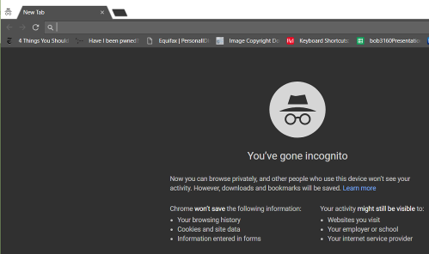

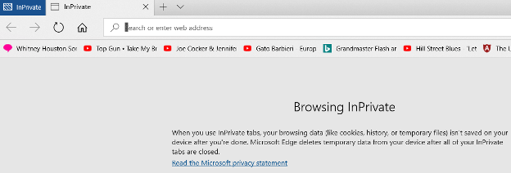
MS Edge - Ctrl-Shift-P

Firefox - Ctrl-Shift-P

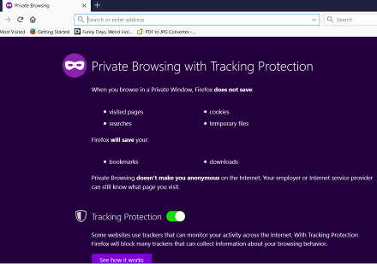

Avast Secure Browser – Ctrl-Shift-N
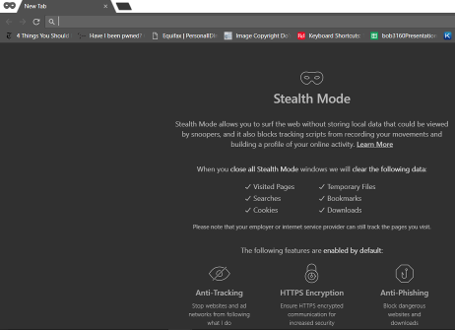

Opera - Ctrl-Shift-N
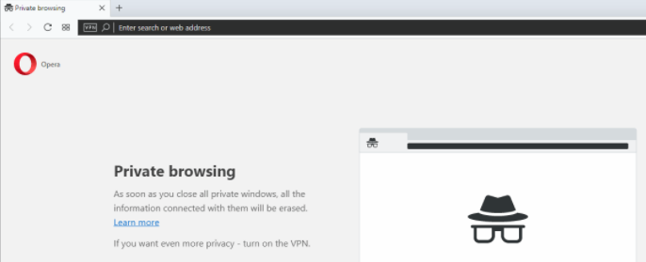

Internet Explorer - Ctrl-Shift-P
